**Recording UPDATES**

1. Standard Types and Subtypes
2. NEW Case Note Recording
3. Standard Required Fields with Error Edits
4. Removal of Custom Forms on new recordings
5. Editing recordings saved in draft
6. Appending saved recordings (not in draft) Active and Inactive boxes
7. Spell check added to Append box
8. Larger Recording Detail box on Add Recording Tab
9. Performance (still under review)

**STANDARD List of Recording Types & Subtypes:**

When adding recordings, please note the NEW STANDARD list of recording types available in the Recording Type dropdown list as pictured below.

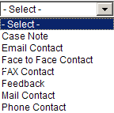

**NEW Case Note Recording:**

Case Note is a new recording type now available to users. The **Case Note** recording type is intended for use ***only when the information being documented does NOT fall into one of the other recording types.*** Examples of appropriate use of the Case Note would be results viewed in various computer systems (Medicaid Eligibility, Webtool, CaseNet, White Pages etc) and/or observations pertinent to the investigation. A good example of an observation one might document as a Case Note would be when an investigation involves trash in RA’s yard and while on the way to a different client’s home the investigator observes the trash has been removed.

**Standard Required Fields with Error Edits:**

The following lists are required fields users must enter data into for the recording to save, by Recording Types. In addition, images from the system display the required field error messages that will present to the user if a required field is blank when user clicks “save”.

**Case Note-Required Fields List:**

Recording Type

Recording Subtype (system will populate after user selects recording type)

Contact Date

Contact Time

Details

**Case Note-Required Fields “Error Edit Image”**

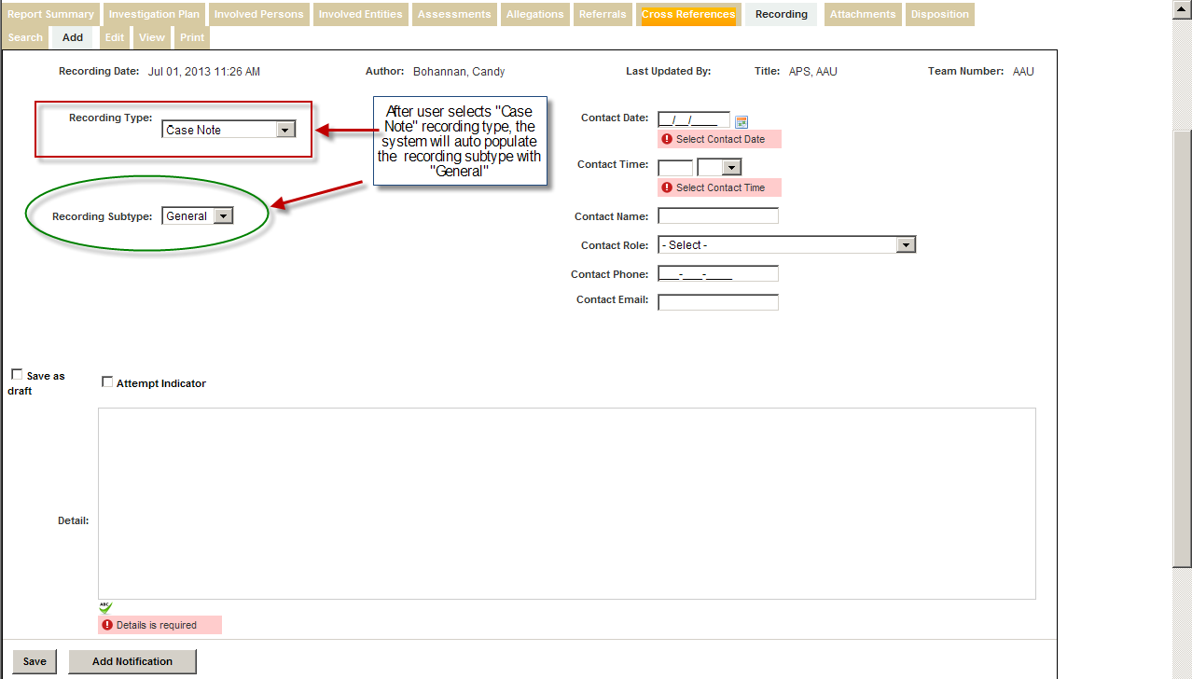

**Email Contact-Required Fields List:**

Recording Type

Recording Subtype

Contact Date

Contact Time

Contact Name

Contact Role

Details

**Email Contact -Required Fields “Error Edit Image”**

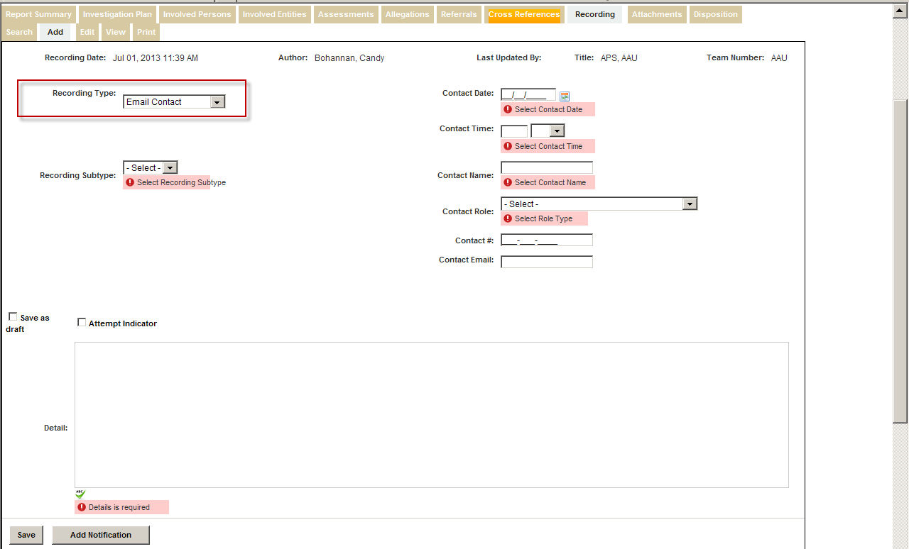

**Face to Face-Required Fields List:**

Recording Type

Recording Subtype

Contact Date

Contact Time

Contact Name

Contact Role

Details

**Face to Face-Required Fields “Error Edit Image”**

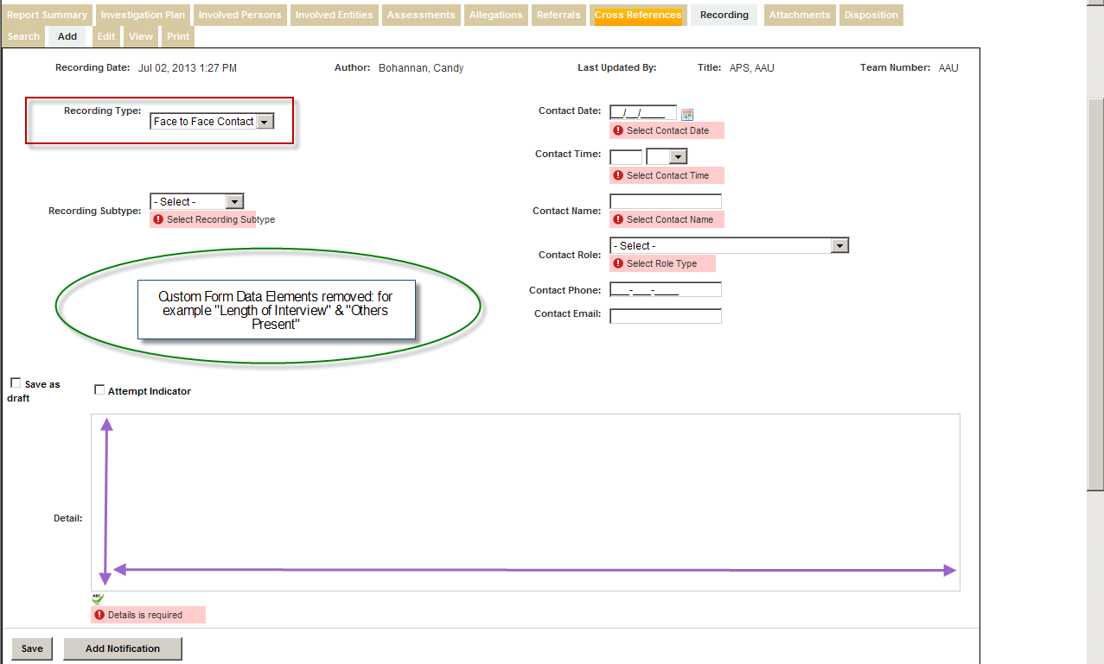

**Removal of Custom Forms on new recordings**

Oval area in above image illustrates where additional optional data elements used to be

**Larger Recording Detail box on Add Recording Tab**

Increased size of Detail box illustrated above with up/down & left/right arrows

**Fax Contact-Required Fields List:**

Recording Type

Recording Subtype

Contact Date

Contact Time

Contact Name

Contact Role

Contact Phone

Details

**Fax Contact-Required Fields “Error Edit Image”**

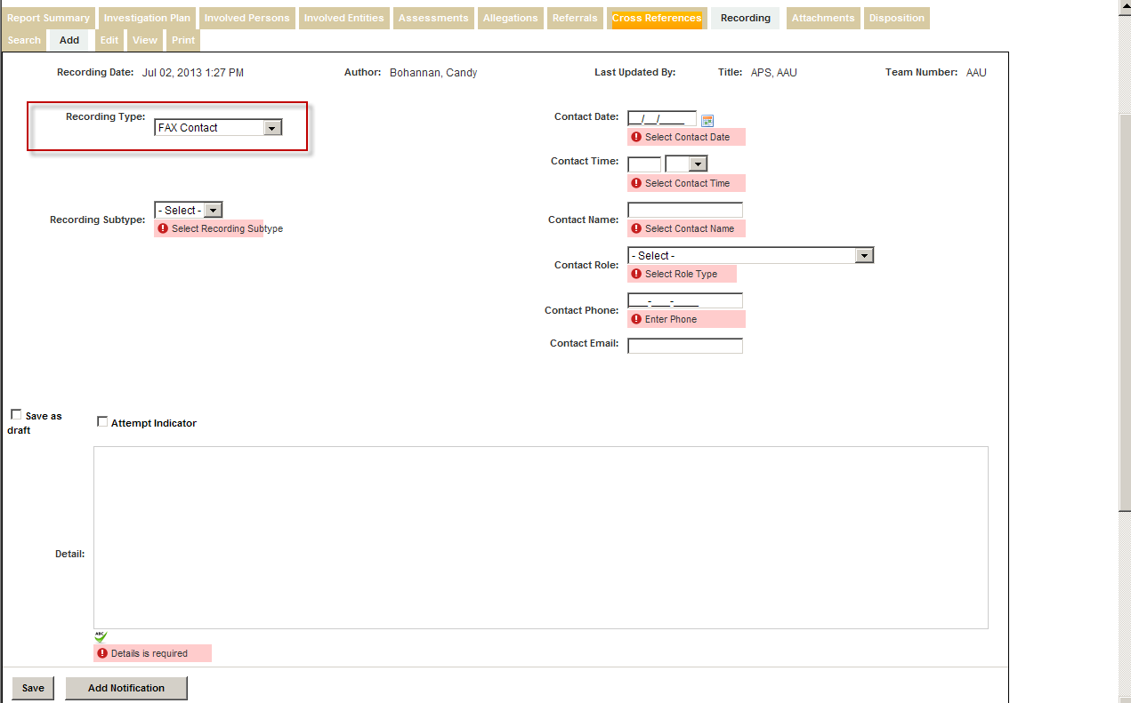

Note the Contact Phone field is required on Fax Contacts

**Feedback-Required Fields List:**

Recording Type

Recording Subtype

Contact Date

Contact Time

Contact Name

Contact Role

Details

**Feedback-Required Fields “Error Edit Image”**

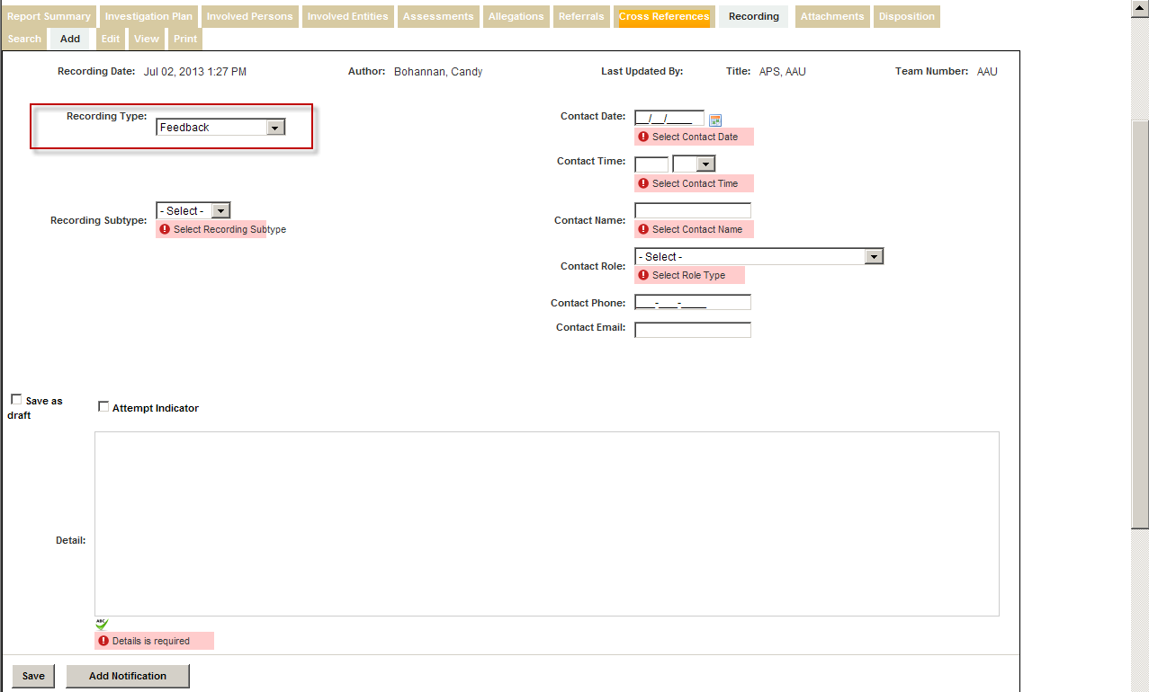

**Mail Contact-Required Fields List:**

Recording Type

Recording Subtype

Contact Date

Contact Time

Contact Name

Contact Role

Details

**Mail Contact-Required Fields “Error Edit Image”**

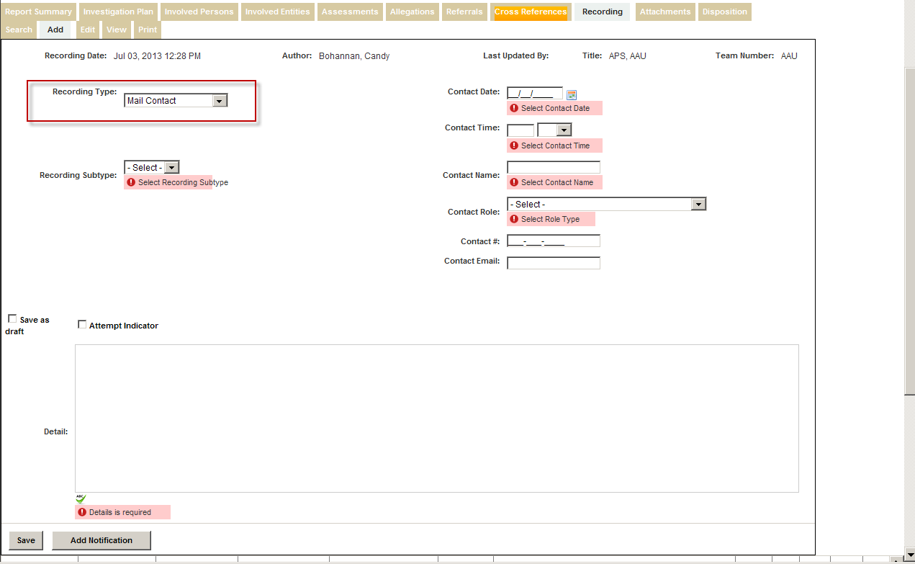

**Phone Contact-Required Fields List:**

Recording Type

Recording Subtype

Contact Date

Contact Time

Contact Name

Contact Role

Contact Phone

Details

**Phone Contact-Required Fields “Error Edit Image”**

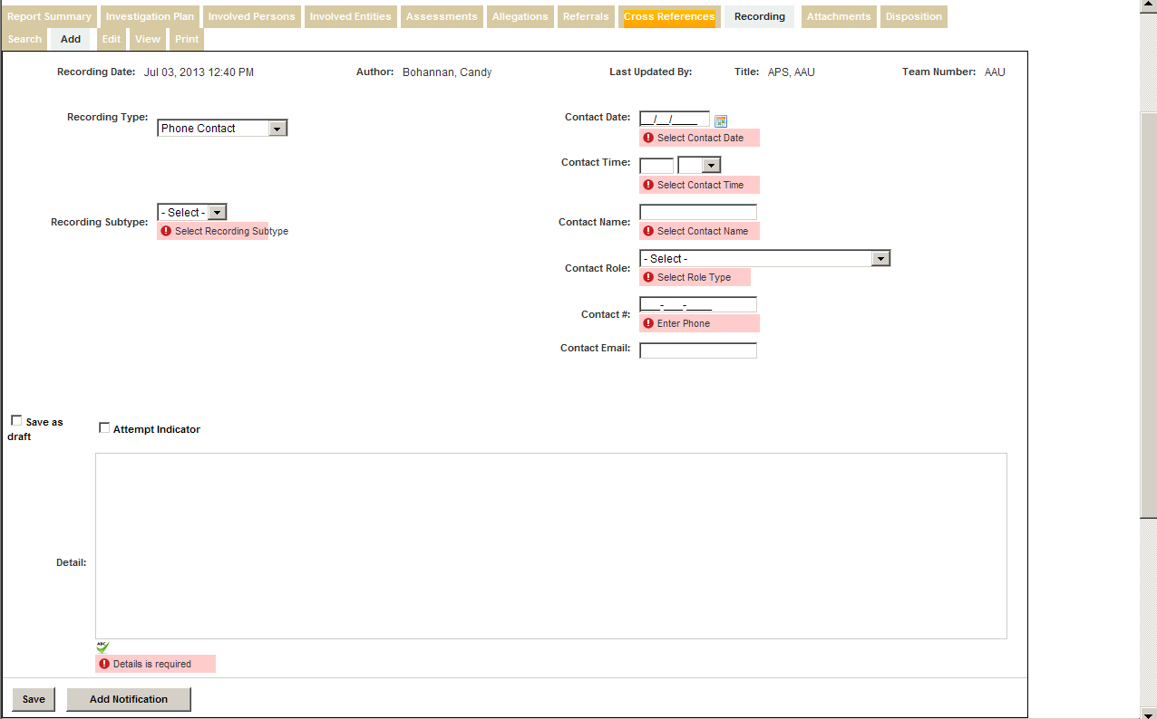

Note the Contact # (Contact Phone) field is required on Phone Contacts

**Functions & Appearance of saved Recordings in the Progression Grid**

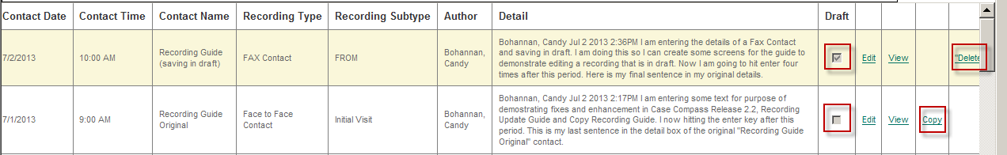

* Recordings saved in draft
  + Edit- user is returned to same screen used to “ADD” the original recording & all fields are still editable
  + View-Can be viewed from the “view” hotlink
  + Copy-can’t be copied, therefore you will not see a “copy” hotlink to the right
  + Delete-by system design can be deleted, thus “delete” hotlink
    - A latent defect was discovered, currently system does not delete draft recordings
* Saved Recordings **NOT** in draft
  + Edit- user is actually “appending” to the original recording; only Append Note box is active
  + View- Can be viewed from the “view” hotlink
  + Copy- Can be copied from “copy” hotlink (see Guide: Expanded Copy Recording Feature)
  + Delte- can’t be deleted, thus no “delete” hotlink

**Example of Editing a Draft Recording:**

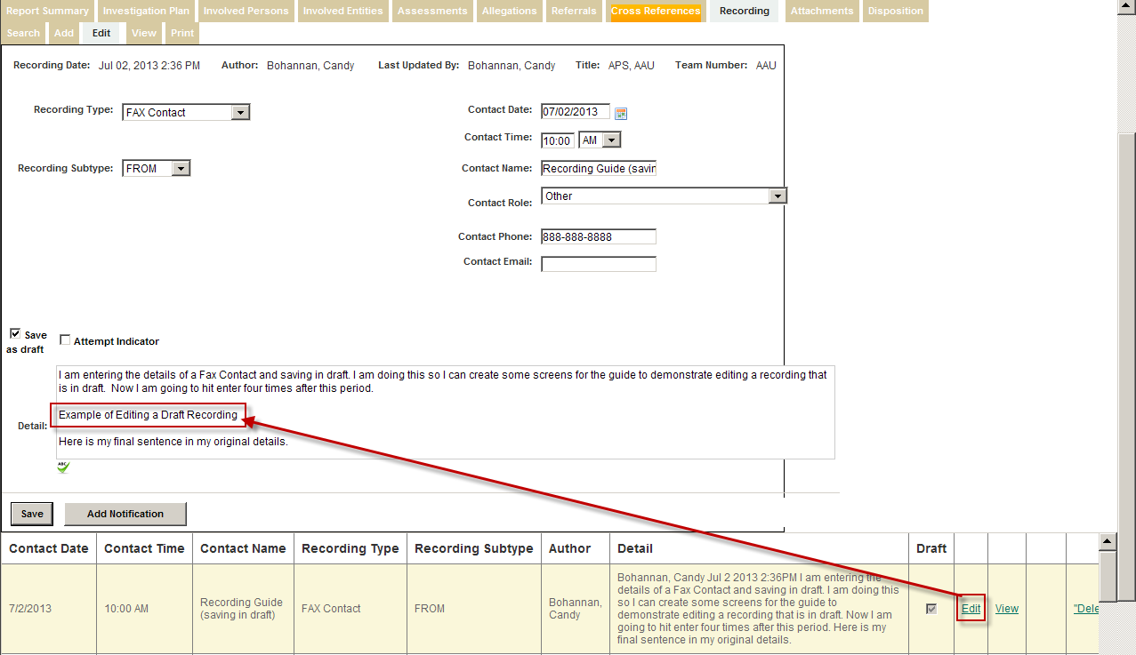

**Result of Editing a DRAFT recording**

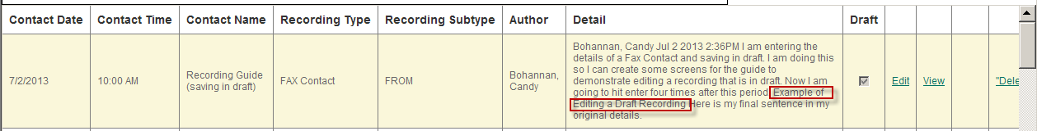

**Example of Editing a Recording NOT in Draft**

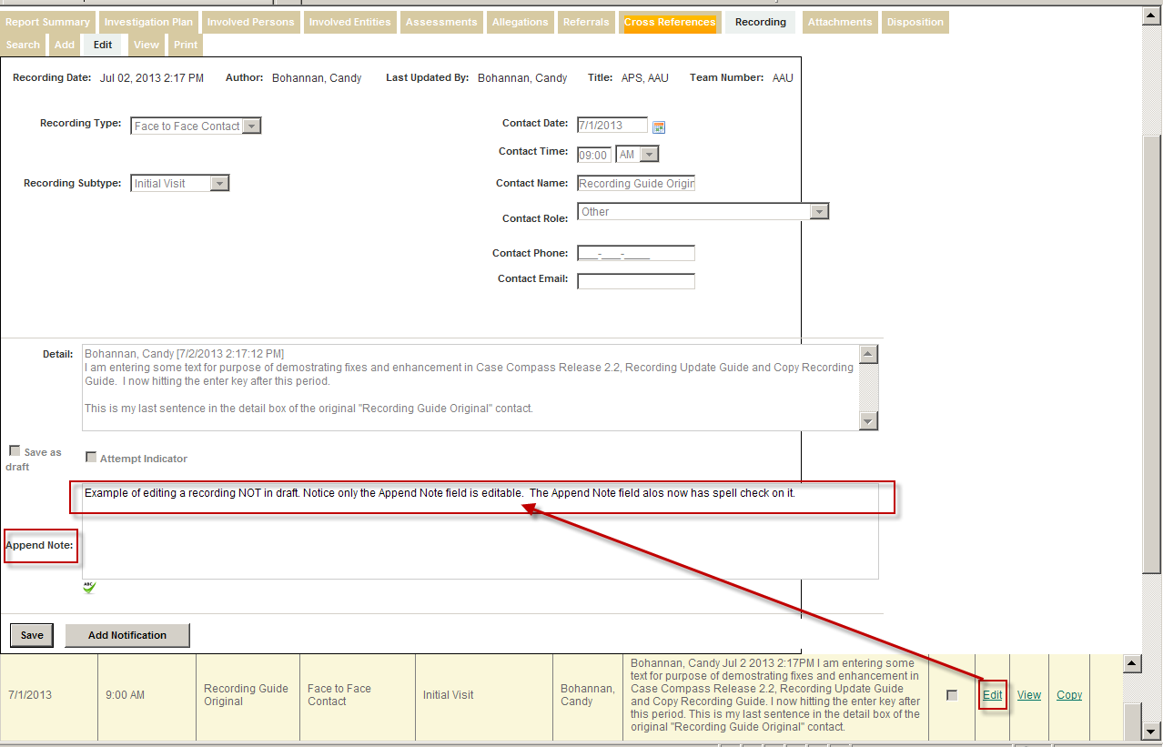

Append Note Field has spell check and is the only active field

**Result of Editing a Recording NOT in Draft**

